



Marketing in
Hospitality and Tourism
HMG 6747| Section R385(11970)| Spring 2026 jnorsworthy@ufl.edu
MARKETING in HOSPITALITY and TOURISM
This course equips students with contemporary knowledge of marketing in the hospitality and tourism sector. The course consists of three main sections: (1) audiences, (2) channels, and (3) integrated execution. The course will explain crucial insights of well-known marketing frameworks and practices while enhancing the learning process through worked examples, cases, and an ongoing, team-based activity applied within a hospitality and tourism setting. Students will be able to differentiate good integrated marketing from poor marketing and will create marketing strategies for their teams in a competitive, multi-period hospitality and tourism simulation. By successfully completing this course, students will enhance the conceptual skills necessary to contribute meaningful insight within the marketing functions of their organizations.

Course Objectives
Upon completion of this course, students will be able to:
- Analyze customer needs/wants/demands and design a value-driven marketing strategy in hospitality and tourism.
- Describe major characteristics affecting consumer behavior and explain the decision processes for individuals and groups.
- Explain how positioning, branding, and differentiation are used to strategically target attractive market segments.
- Determine pricing policy, promotional decisions, and channel management to communicate and capture value created.
- Integrate data and digital marketing into all aspects of an integrated marketing philosophy.
- Create a comprehensive marketing plan in the hospitality and tourism industry.

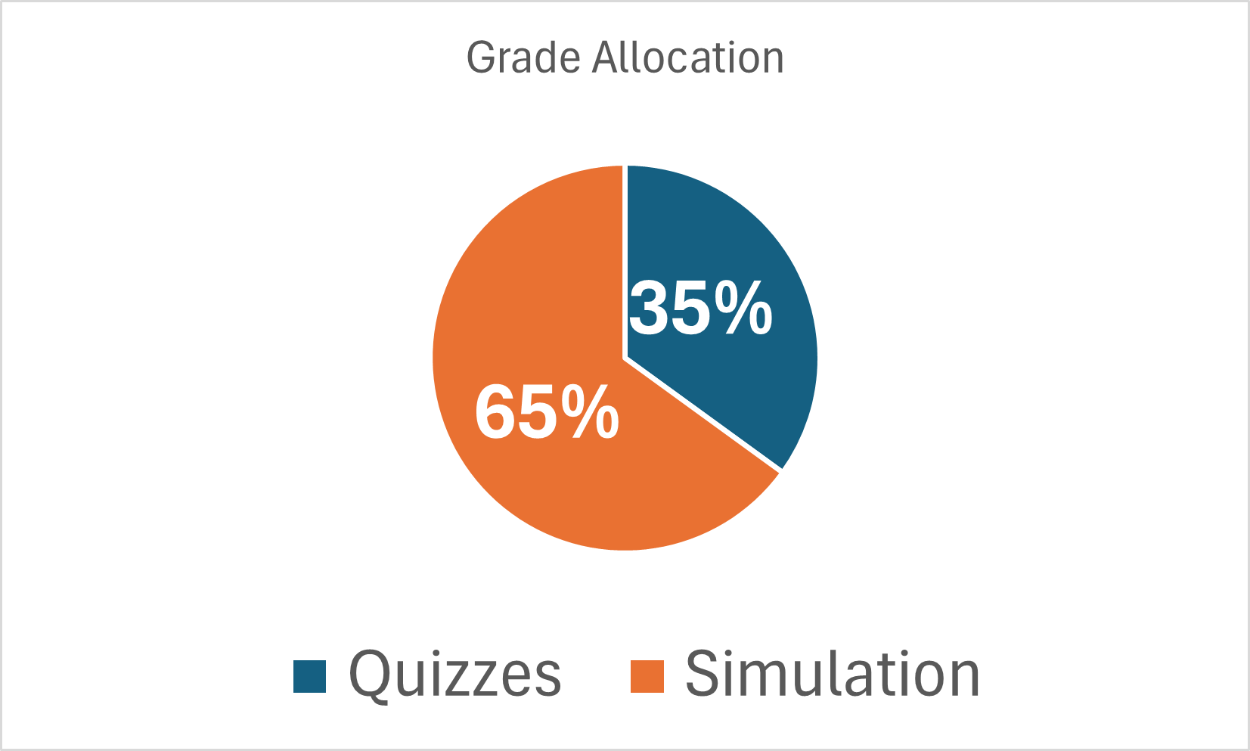
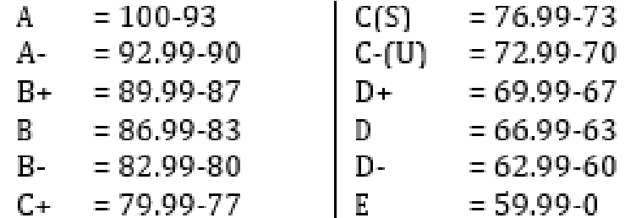
Instructor Course Requirements
Joe Norsworthy 65% - Hubro Simulation
Executive in Residence 35% - Quizzes
jnorsworthy@ufl.edu

Grading Standards
See current UF Grading Policies for further details:

https://catalog.ufl.edu/ugrad/current/regulations/info/grades.aspx

Text & Reading Material
• Kotler, P., Bowen J., & Baloglu, S. (2020). Marketing for Hospitality and Tourism (8th ed.). Pearson. ©2021. Order eTextbook here: https://www.pearson.com/en-us/subject-catalog/p/marketing-for-hospitality-and-tourism/P200000001367?view=student
Additional Readings in required course pack and posted to Canvas.

Course Schedule
Week # | Readings |  | Assignment | Due Date | Point Value
Week #1 | Text Chapters 1, 2, 6, 7  Marketing Reading: Consumer Behavior and the Buying Process (course pack) | • | Quiz 1 | Jan 18 | 50 points
Week #2 | Text Chapters 8, 9  Marketing Reading: Segmentation and Targeting (course pack) | • • • | Simulation Round 1 team decisions entry  Simulation Round 2 team decisions entry  Quiz 2 | Jan 22  Jan 22  Jan 25 | 0 points  0 points  50 points
Week #3 | Text Chapters 11, 12  Storytelling That Drives Bold Change (course pack) | • • • • | Simulation Round 3 team decisions entry  Simulation Round 4 team decisions entry  Simulation team report 1  Quiz 3 | Jan 29  Jan 29  Feb 1  Feb 1 | 0 points  0 points  125 points  50 points
Week #4 | Text Chapters 13, 14 | • • • | Simulation Round 5 team decisions entry  Simulation Round 6 team decisions entry  Quiz 4 | Feb 5  Feb 5  Feb 8 | 0 points  0 points  50 points
Week #5 | Text Chapters 5, 16 | • • • •  • | Simulation Round 7 team decisions entry  Simulation Round 8 team decisions entry  In-class guest and discussion  Simulation team report 2  Quiz 5 | Feb 12  Feb 12  Feb 10  Feb 15  Feb 15 | 0 points  0 points  125 points  50 points
Week #6 | Text Chapters 15, 17 | • • • | Simulation Round 9 team decisions entry  Simulation Round 10 team decisions entry  Quiz 6 | Feb 19  Feb 19  Feb 22 | 0 points  0 points  50 points
Week #7 | Text Chapters 10, 18 | • • • •  •  • | Simulation Round 11 team decisions entry  Simulation Round 12 team decisions entry  Final Simulation team report  Individual Simulation Report (NOTE DATE)  Quiz 7 (NOTE DATE)  Simulation Team Results (no submission) | Feb 24  Feb 24  Feb 27  Feb 27  Feb 27 | 0 points  0 points  125 points  75 points  50 points  200 points
Finals Week |  | • | No Final

Course Requirements
The assignments will be used to assess the student’s academic standing in this course. Late assignments will not be accepted for credit unless arrangements have been made with the instructor prior to the due date for that particular assignment. Failure to make prior arrangements may result in rejection of work submitted late. Requirements for class attendance and make-up exams, assignments, and other work are consistent with university policies: https://catalog.ufl.edu/ugrad/current/regulations/info/attendance.aspx.

65% - Hubro Hospitality Marketing Simulation
3 Team Reports X 125 points each = 375 points total
1 Individual Simulation Report that evaluates team performance plus teammate and personal contributions = 75 points
Team Balanced Scorecard Results = 200 points
Overview: Students are required to participate as a team member in Hubro Simulations: Strategic Marketing. The primary purpose of the simulation is to create opportunities for students to apply course knowledge in a competitive hospitality business environment – in this case as a team leading a simulated pizza chain.
• Students must register for the simulation on the first day of class at this URL (student price $81)
https://hbsp.harvard.edu/import/1374299
- Teams assigned by the instructor. See detailed instructions for information about requesting a specific teammate.
- Simulation Rounds 1-12 decisions are submitted IN THE SIMULATION (i.e., not Canvas) every Thursday in class beginning January 22 and ending Tuesday, February 24.
- Team weekly reports are due at 11:59pm on Sunday, Feb 1, Sunday, Feb 15 and on Friday, Feb 27. Individual Report is due Friday, Feb 27 at 11:59pm
- Balanced Scorecard results points are either: (1) 200 pts for 1st place, 190 2nd. 180 3rd, 170 4th, 160 5th place; or (2) proportion to first place, whichever points total is higher.
Additional information about the simulation assignments and reports will be explained in Canvas announcements.

35% - Quizzes
7 Quizzes, 350 points total (50 points per quiz)
Overview: Students will be assessed throughout the semester by taking 7 quizzes.
Students are required to complete quizzes in Canvas by due date assigned. Point value is 50 per quiz. Please review each quiz’s instructions & guidelines.
- Students will be assessed over all course materials: readings, videos, lectures, etc.
- Quizzes are open note, open book but MUST be done independently, without help or assistance from any other person
Course Policies & Information
Students should be aware that online learning is different than a traditional classroom experience and can present unique challenges, particularly to individuals who do not possess good time management skills. The online classroom is available to you 24 hours a day. Unlike traditional instructional settings in which each student gets the same class at a set time and day, the online setting gives students the opportunity to tailor class to their particular learning style. You should note, however, that this course is not completely self- paced. As listed on the class calendar, there are select times during which units and course materials will be available and are due. You can view each unit’s lectures at any time during the dates in which that specific unit is open. Please note that all quizzes, exams, assignments, discussion posts, etc. must be completed and submitted by the due date listed on the syllabus. Quizzes and exams will only be available to you on the date(s) and time(s) listed on the syllabus. Since we will not have in-class meeting times for me to remind you of critical dates, it is essential to familiarize yourself with the course schedule, deadlines, and due dates.
Make Up Policy:
Assignments/Quizzes/Discussion posts/etc. will not be accepted late, and on some days more than one of these tasks may be due. If personal circumstances arise that may interfere with your ability to meet a deadline, please let me know as soon as possible before the due date. Please keep in mind only university authorized excuses will be accepted, and documentation must be provided. Requirements for make-up exams, assignments, and other work are consistent with university policies: https://catalog.ufl.edu/ugrad/current/regulations/info/attendance.aspx
Communication and Questions:
Students are responsible for getting a University of Florida email account (e.g., john.doe@ufl.edu) and should use this email for all university related correspondence – The instructor may not read emails from or send emails to any non-UF email addresses (e.g., john.doe@hotmail.com). Email subject should start with “SPM 4723 – First name, Last name - …” Email use does not relieve students from the responsibility of confirming the communication with the instructor. Always sign your email – don’t make the instructor guess from whom the email was sent. The instructor will answer your email within two business days, when possible.
You may email me through the course site with any questions or concerns you have, and I will attempt to respond to your emails within 48 hours (typically sooner). If you have an urgent issue, please email my personal UF email, jnorsworthy@ufl.edu.
For general course questions, I encourage you to check the Course Questions Discussion Board since other students may have the same question. If you do not find an answer, post your question using a descriptive subject line. All students are expected to follow rules of common courtesy in email messages, discussions, chats, etc. Please review the Netiquette Guide (also on course website) for further important information.
University Policy on Accommodating Students with Disabilities:
Students with disabilities requesting accommodations should first register with the Disability Resource (DSR) Center (352-392-
8565; www.dso.ufl.edu/drc/) by providing appropriate documentation. Once registered, students will receive an accommodation letter which must be presented to the instructor when requesting accommodation. You must submit this documentation to your instructor prior to submitting assignments or taking the quizzes or exams. Accommodations are not retroactive, therefore, students should contact the DSR office as soon as possible in the term for which they are seeking accommodations
Honor Code Policy:

“We, the members of the University of Florida community, pledge to hold ourselves and our peers to the highest standards of honesty and integrity.”
The following pledge will be either required or implied on all work:
“On my honor, I have neither given nor received unauthorized aid in doing this assignment.”
It is the duty of the student to abide by all rules set forth in the UF Undergraduate Catalog. Students are responsible for reporting any circumstances, which may facilitate academic dishonesty. University Policy on Academic Misconduct: Academic honesty and integrity are fundamental values of the University community. Students should be sure that they understand the UF Student Honor Code at: https://sccr.dso.ufl.edu/policies/student-honor-code-student-conduct-code/
Honorlock Quiz and Exam Proctoring Information:
Honorlock will proctor your quizzes and examinations this semester. Honorlock is an online proctoring service that allows you to take your exam from the comfort of your home. You DO NOT need to create an account, download software or schedule an appointment in advance. Honorlock is available 24/7 and all that is needed is a computer, a working webam, and a stable internet connection.
To get started, you will need Google Chrome and to download the Honorlock Chrome Extension. You can download the extension at wwww.honorlock.com/extension/install
When you are ready to test, log into Canvas/E-Learning, go to your course, and click on your exam. Clicking launch Proctoring will begin the Honorlock authentication process, where you will take a picture of yourself, show your ID, and complete a scan of your room. Honorlock will be recording your exam session by webcam as well as recording your screen. Honorlock also has an integrity algorithm that can detect search-engine use, so please do not attempt to search for answers, even if it’s on a secondary device.
Honorlock support is available 24/7/365. If you encounter any issues, you may contact Honorlock by live chat, phone (844243-2500), and/or email (support@honorlock.com)
Academic Integrity:
All students must adhere to university regulations regarding academic integrity. Any form of academic dishonesty (including but not limited to any form of cheating, plagiarism, misrepresentation, etc.) will not be tolerated. Any student guilty of academic dishonesty will receive a failing grade (E) for the course, and the matter will be forwarded to the UF Office Student Affairs and the Dean of Students.
Grade Appeal Policy:
Should you want to contest a grade, you will have up to three (3) days after a grade has been posted to contact me and discuss your issue; after which the grade is final. Grades are based on a point scale and will not be rounded.

Getting Help:
The University of Florida recognizes that pursuit of an online degree requires just as much student support as pursuit of a traditional on-campus degree and, therefore, each online program is responsible for providing the same student support services to both students who are in residence on the main campus and those who are seeking an online degree through distance learning. The following links provide support services for students:
Online Computing Help Desk- e-Learning Support Services
The UF Computing Help Desk is available to assist students with technical issues. If you have any issues accessing the online course material you must contact the UF Computing Help Desk immediately for assistance and obtain a case number. I will not accept late assignments, or change any course dates, due to technology difficulties if you do not have a case number prior to the due date for the assignment.
For issues with technical difficulties in E-learning, please contact the UF Help Desk:
helpdesk@ufl.edu (352) 392-4357 https://elearning.ufl.edu/student-help-faqs/
Other resources are available at: https://distance.ufl.edu/getting-help/
Online Library Help Desk
The help desk is available to assist students with access to all of the UF Libraries resources.
Disabilities Resource Center
Students requesting classroom accommodation must first register with the Dean of Students Office. The Dean of Students Office will provide documentation to the student who must then provide this documentation to the Instructor when requesting accommodation. If you have a physical, learning, sensory or psychological disability, please visit our Disabilities Resource Center.

Campus Resources
U Matter, We Care - Your well-being is important to the University of Florida. The U Matter, We Care initiative is committed to creating a culture of care on our campus by encouraging members of our community to look out for one another and to reach out for help if a member of our community is in need. If you or a friend is in distress, please contact umatter@ufl.edu so that the U Matter, We Care Team can reach out to the student in distress. A nighttime and weekend crisis counselor is available by phone at 352-392-1575. The U Matter, We Care Team can help connect students to the many other helping resources available including, but not limited to, Victim Advocates, Housing staff, and the Counseling and Wellness Center. Please remember that asking for help is a sign of strength. In case of emergency, call 9-1-1.

Student Privacy
There are federal laws protecting your privacy with regards to grades earned in courses and on individual assignments. For more information, please see the Notification to Students of FERPA Rights.
Health and Wellness
Counseling and Wellness Center: counseling.ufl.edu/cwc, and 392-1575; and the University Police Department: 392-1111 or 9-1-1 for emergencies.
Sexual Assault Recovery Services (SARS) Student Health Care Center, 392-1161.
University Police Department at 392-1111 (or 9-1-1 for emergencies), or police.ufl.edu.
Academic Resources
E-learning technical support, 352-392-4357 (select option 2) or e-mail to Learning-support@ufl.edu.
Career Resource Center, Reitz Union, 392-1601. Career assistance and counseling.
Library Support, Various ways to receive assistance with respect to using the libraries or finding resources.
Teaching Center, Broward Hall, 392-2010 or 392-6420. General study skills and tutoring.
Writing Studio, 302 Tigert Hall, 846-1138. Help brainstorming, formatting, and writing papers.
Student Complaints Campus On-Line Students Complaints
Copyright Statement:
The materials used in this course are copyrighted. The content presented is the property of UF and may not be duplicated in any format without permission from the College of Health and Human Performance and UF, and may not be used for any commercial purposes.
Content includes but is not limited to syllabi, videos, slides, quizzes, exams, lab problems, in-class materials, review sheets, and additional problem sets. Because these materials are copyrighted, you do not have the right to copy or distribute the course materials, unless permission is expressly granted. Students violating this policy may be subject to disciplinary action under the UF Conduct Code.
Disclaimer: This syllabus represents the objectives and tentative plans for the course. As we go through the semester, those plans may need to change to enhance the class learning opportunity. Such changes, will be communicated clearly, are not unusual, and should be expected.

