 | @UFHHP
 | @ufhhp
 | @UF_HHP
 | APK LinkedIn



Strength and Conditioning for
Connect with HHP

Beginning Practitioners

APK5177 | 3 Credits | Spring 2026

Course Info
INSTRUCTOR | Christopher Brown, PhD, LAT, ATC, CSCS, TSAC-F, PES, OPE-C  Clinical Associate Professor  Clinical Education Coordinator, Doctor of Athletic Training Program  Office Location: 122FLG  Email: cdbrown7@ufl.edu
OFFICE HOURS | Office Hours: Will be held for 2 hours each week and the schedule will be posted on CANVAS.  If you would like an appointment, please click HERE
MEETING TIME/LOCATION | Access course through Canvas on UF e-Learning & the Canvas mobile app by Instructure

COURSE DESCRIPTION
This course addresses the principles of designing training programs of varying duration aimed at improving muscular strength, power, speed, agility, endurance, balance, stability, and hypertrophy. Emphasis will be placed on creating and administering evidence-based periodized training programs and ensuring safe and productive technique of fundamental exercises in each modality.

PREREQUISITE KNOWLEDGE AND SKILLS
There are no prerequisites to the course.

REQUIRED AND RECOMMENDED MATERIALS
Textbook | ISBN
Essentials of Strength and Conditioning  Author: National Strength and Conditioning Association Publisher: Human Kinetics Year: 2015 Edition: 4th | 9781492501626 | Required
Exercise Technique Manual for Resistance Training Author: National Strength and Conditioning Association Publisher: Human Kinetics Year: 2022 Edition: 4th | 9781718211704 | Recommended
All other reading materials will be available on the class web page (E-Learning)
Please view course fees (if applicable)

COURSE FORMAT
This course will utilize a lecture and assignment approach. You will be able to watch lectures on CANVAS and participate in discussions/assignments within the CANVAS shell. I will provide PowerPoint slides for you to access for information about specific points. You will need to review this information as well as the information in the textbook and from alternative readings for this course. You will be expected to be active learners outside of the classroom.

COURSE LEARNING OBJECTIVES:
- Identify the biomechanical factors that influence resistance training performance
- Describe the basic physiology of the skeletal, neuromuscular, and cardiovascular systems as they pertain to an athlete engaged in a strength and conditioning program
- Predict the expected physiological adaptations of anaerobic and aerobic training programs.
- Conduct a needs analysis of a sport and an athlete within the sport
- Create a periodized annual strength and conditioning program integrating training modalities relevant to a chosen sport
- Administer appropriate assessments of athletic performance and interpret test results.
- Prescribe exercise training sessions with the intention of improving athletic performance in the areas of strength, power, speed, agility, aerobic capacity, anaerobic capacity, hypertrophy, and flexibility
- Adjust exercise prescriptions to meet the unique needs of youth and masters athletes
- Recommend evidence-based post-training recovery strategies to athletes.
- Identify facility administration safety considerations to limit liability risk
- Sit for the NSCA CSCS exam if desired.

University Policies

University policy is listed here

Course Policies

Appropriate Use of AI Technology
The UF Honor Code strictly prohibits cheating. The use of any materials or resources prepared by another person or Entity (inclusive of generative AI tools) without the other person or Entity’s express consent or without proper attribution to the other person or Entity is considered cheating. Additionally, the use of any materials or resources, through any medium, which the Faculty / Instructor has not given express permission to use and that may confer an academic benefit to a student, constitutes cheating. The use of AI tools will facilitate student development of skills and knowledge acquisition within the stated learning objectives of the course and are permitted in this course. When students opt to leverage AI tools to augment their submitted products, they will be expected to appropriately cite the tool(s) utilized. Further, students will be held accountable under the scope of the UF Student Honor Code & Conduct Code for the content of all work they submit (including the portions that may have been produced in part or whole by an external Entity—including AI). Thus, students should engage in active editorial and underwriting efforts to ensure the totality of the work submitted reflects their intentions and ethical values.

EXAM MAKE-UP POLICY
There will be NO make-up examinations unless exceptional conditions occur (as defined in the University of Florida Undergraduate Catalog). Prior permission from the professor is required. There will be a time limit for each examination. Examinations will evaluate the understanding of material from lecture, text, and other supplemental material provided.

COURSE EVALUATIONS
- The email they receive from GatorEvals,
- Their Canvas course menu under GatorEvals,
- The central portal
  - Guidance on how to provide constructive feedback is available here.
  - Students will be notified when the evaluation period opens. Summaries of course evaluation results are available to students here

APK ADMINISTRATORS
For suggestions or concerns related to APK courses or programming, please reach out to any of the following:
- Dr. David Vaillancourt, APK Department Chair, vcourt@ufl.edu
- Dr. Demetra Christou, APK Department Vice Chair, ddchristou@hhp.ufl.edu
- Dr. Steve Coombes, APK Graduate Coordinator, rachaelseidler@ufl.edu
- Dr. Anna Gardner, APK Undergraduate Coordinator, akgardner@ufl.edu

Grading
Students will earn their course grade based on completion of coursework as outlined in the Grading Criteria listed below. Percentage calculations are rounded up at “.6 or above” and rounded down at “.5 or below”. For more information regarding Grade Point Averages, Grade Values, etc. please visit the University registrar website

GRADING CRITERIA
Letter Grade | Grade Points | Percentage
A | 4.00 | 100-91.5
A- | 3.67 | 91.4-88.5
B+ | 3.33 | 88.4-86.5
B | 3.00 | 86.4-79.5
C+ | 2.33 | 79.4-76.5
C | 2.00 | 76.4-71.5
D+ | 1.33 | 71.4-69.5
D | 1.00 | 69.4-59.5
E | 0.00 | Below 59.5

ASSIGNMENTS
- Quizzes (12) 20%
- Program Design Assignments (7) 21%
- Exam #1 20%
- Exam #2 20%
- Discussions 10%
- Article Reviews (3) 9%

Quizzes:
- You have up to 3 attempts to answer all questions correctly
- You will be unable to see your responses or the correct answers between attempts.
- The highest score will be kept as your score.
- The quiz is untimed so please take all the time you need on each attempt.
- The quiz is open book and open note.
- Answers will display for 24 hours once the quiz has closed.

Program Design Assignments:
- These assignments give a chance to showcase the practical skills learned in select modules by designing a program for a select client or group of athletes
- Each program will be evaluated by a random peer in the course. The Peer evaluator will be randomly assigned by CANVAS.
- These assignments are graded as Complete/Incomplete

Exam #1:
- The exam is 50 questions, all multiple-choice.
- Each question only has three answer choices.
- I won't know what questions you'll get until after you take the exam.
- 50 Questions will be randomly pulled from the exam banks.
  - 45 from the general bank
  - 5 from the research articles bank
- You are allowed 2 attempts on the exam. You will be not able to view the questions and your answers between attempts. The highest score from the 2 attempts is used in calculating your final grade.
- You will not be able to see correct answers until after the exam window has passed.
  - Exam questions and correct answers will be posted the day after the Exam for 24 hours.
- The exam is not timed, but you can't work on it past the Due Date/Time. Be finished before then.
  - Keep in mind the exam is on Eastern Standard Time for those in different time zones.
- Honorlock will be on during the exam. There is a basic calculator. Notes, scratch paper, and textbook are NOT permitted (different than quizzes).
Exam #2:
- The exam is 65 questions, all multiple choice.
  - 14 questions will be pulled from the Exam #1 question bank
  - 51 questions will be from the Exam #2 question bank
- Each question only has three answer choices.
- You are allowed 2 attempts on the exam. You will be not able to view the questions and your answers between attempts. The highest score from the 2 attempts is used in calculating your final grade.
- These questions may involve the assigned chapter(s) in the modules, the assigned research article(s) in the modules. While some questions may overlap the 2 attempts, you should not expect the second attempt to be identical to the first.
- You will not be able to see correct answers until after the exam window has passed.
- Exam questions and correct answers will be posted the day after the Exam for 24 hours The exam is not timed, but you can't work on it past the Due Date/Time. Be finished before then.
  - Keep in mind the exam is on Eastern Standard Time for those in different time zones.
- Honorlock will be on during the exam. There is a basic calculator. Notes, scratch paper, and textbook are NOT permitted (different than quizzes).

Discussions:
- This is the online discussion posting board for the course.
- Content will be based on course materials
- Rubric:
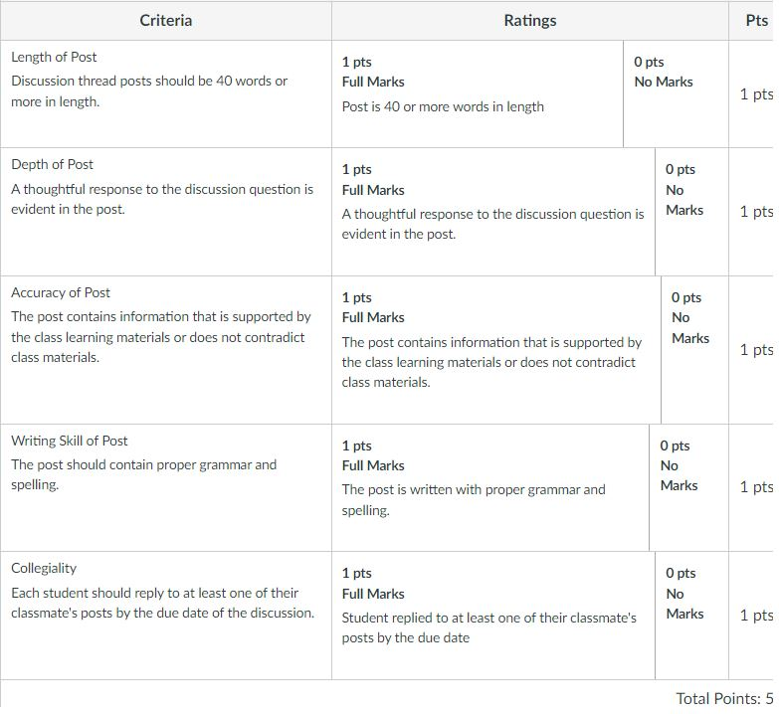

Article Reviews:
- Students are expected to post 3 research article synopses to CANVAS by the Due Date. Each article synopsis requires students to search a relevant database of research journals (i.e. Google Scholar, SportDiscus, PubMed) to find a peer-reviewed research article related to one of the course topics. Students should read the selected articles in their entirety.
- The synopsis should be written and should include the following headers:
  - Reason for Selection
  - Research Problem
  - Methods
  - Results/Conclusions
  - Takeaways.
- Students should briefly summarize why they selected the article, what research problem was addressed in the article, how the experiment was conducted, the most important results and explanations for the results provided by the authors of the study, and what information from the article can be used by classmates in their strength and conditioning decision making processes.
- All assignments will be automatically graded by Turn-it-in upon submission. Results should show blue or green.
- Please include a citation or copy of the article with the assignment.
- Rubric:
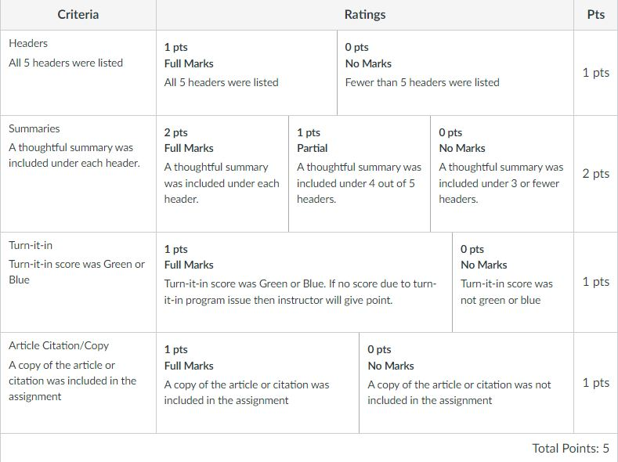

Weekly Course Schedule
Module Start | Topics | Assignments | Assignment Due Date
Jan 12th | Syllabus/Introduction | S&C History: Quiz  Discussions Due Throughout Semester | Jan 25th
Jan 12th | Body Systems and  Bioenergetics | Chapter 1&3: Quiz  Program Design: Bioenergetics | Jan 25th
Jan 12th | Age and Sex | Chapter 7 Quiz | Jan 25th
Jan 26th | Testing | Chapter 12-13: Quiz  Program Design: Testing | Feb 8th
Jan 26th | Warm-up/Flexibility | Chapter 14: Quiz  Program Design: Warm-up/Flexibility | Feb 8th
Feb 9th | Exercise Technique | Chapter 15-16: Quiz  Article Review #1 | Feb 22nd
Feb 9th | Program Design | Chapter 17: Quiz  Program Design: Resistance Training | Feb 22nd
Feb 23rd | Exam #1 |  | Mar 1st
Mar 2nd | Plyometrics | Chapter 18: Quiz  Program Design: Plyometrics | Mar 22nd
Mar 2nd | Speed and Agility/Aerobic | Chapter 19-20: Quiz  Article Review #2 | Mar 22nd
Mar 23rd | Periodization | Chapter 21: Quiz  Program Design: Periodization | Apr 5th
Mar 23rd | Recovery | Program Design: Recovery | Apr 5th
Apr 6th | Biomechanics | Chapter 2: Quiz | Apr 19th
Apr 6th | Facility Design/Legal | Chapter 23-24: Quiz  Article Review #3  Discussions Due Throughout Semester | Apr 19th
Apr 20th | Exam #2 |  | Apr 26th

*All Assignments are due by 11:59pm EST of the date listed.

