Health & Medical Terminology

HSC 5536c

3 credit hours

Fall 2024

online
Instructor: Amber S. Emanuel, Ph.D.
Florida Gym, Room 126
amberemanuel@ufl.edu

Virtual Office Hours: Please email (amberemanuel@ufl.edu) or message through Canvas to schedule a time to virtually meet

Course Website: http://elearning.ufl.edu

Course Communications:
- Email: amberemanuel@ufl.edu
  - I will respond to emails within 24 hours during the week day, and within 48 hours over the weekend. Please take this into account when emailing.
- Additionally, you should make a point to regularly check for course-related notices via the Announcement tool on the Canvas course website. Students who fail to keep up with posted Announcements risk missing important information related to the course, including possible changes in assignment due dates.

E-Text (HIGHLY RECOMMENDED):
Our textbook is Cohen, B.J. & Jones, S.A. (2021). Medical Terminology: An Illustrated Guide. 9th Edition.
- no access code needed

Course Description: Medical terminology is the study of the principles of medical word building to help the student develop the extensive medical vocabulary used in health care occupations. Alongside studying the principles of medical word building to help you develop the extensive medical vocabulary used in healthcare occupations, we will build on this foundational knowledge to help you feel more confident using medical terminology in your profession.

Course Goals and/or Objectives: Upon completion of HSC5536c, you will be able to:
- List suffixes, prefixes, and word roots common to medical terminology
- Define suffixes, prefixes, and word roots common to medical terminology
- Construct medical terms correctly using the appropriate suffixes, prefixes, and word roots
- List suffixes, prefixes, and word roots common to specific organ systems of the human body
- Construct system-specific medical terms using the correct suffixes, prefixes, and word roots
- Become familiar with how to use medical terminology in interacting with both other healthcare professionals and with patients, demonstrating an ability to use both technical medical terminology and the "living room language" version of medical terms.

Inclusive learning statement: Your success in this class—and at UF and beyond—is important to me. I strive to provide an environment that is equitable and conducive to achievement and learning for all students. I ask that we all be respectful of diverse opinions and of all class members.
If there are circumstances that may affect your performance in this class, please let me know as soon as possible so that we can work together to develop strategies to meet both your needs and the needs of the course. I recognize that there are many reasons students may need to adjust their pace, style, or method of learning, including but not limited to disability, temporary or ongoing personal life circumstances, unexpected emergencies, or other learning differences. You need not have a specific reason or diagnosis to talk to me about your needs; everyone deserves to learn in the way that makes the most sense for them at any point in time. Every possible effort will be made to accommodate you to help you succeed.

Instructional Methods: The instructional methods used in this course include: video lectures, flashcards, self-testing quizzes, a midterm, and a final.
- Introductory discussion- The introduction discussion helps us get to know each other.
- Flashcards- For most modules, you will create your own flashcards of the key medical terminology (prefixes, suffixes, root terms, etc.) to help you learn.
- Worksheets- Each module has a worksheet that will get you to practice building medical terminology.
- Quizzes- Quizzes will help you gauge your learning for each module.
- Medical Communication Assignments – various assignments (see examples below)
  - Patient/Provider Interaction Activity- This activity will help you think about how to best communicate healthcare information to patients.
  - Medical Terminology Analysis-Every discipline evolves and grows, and medical terminology is no different. In these activities, you will be introduced to current critiques of medical terminology in the field and provide a reflection.
- A final, cumulative (all chapters) examination. The exam will be on Canvas, and will be proctored through Honorlock. It will cover all module content.

HONORLOCK:
Honorlock will proctor your exams this semester. Honorlock is an online proctoring service that allows you to take your exam from the comfort of your home. You DO NOT need to create an account, download software or schedule an appointment in advance. Honorlock is available 24/7 and all that is needed is a computer, a working webcam, and a stable Internet connection. Please see the Honorlock page in Canvas for more information.

UF Policies:
University Policy on Accommodating Students with Disabilities: Students with disabilities requesting accommodations should first register with the Disability Resource Center (352-392-8565, www.dso.ufl.edu/drc ) by providing appropriate documentation. Once registered, students will receive an accommodation letter which must be presented to the instructor when requesting accommodation. Students with disabilities should follow this procedure as early as possible in the semester.

University Policy on Academic Conduct:

University of Florida students are bound by the Honor Pledge. On all work submitted for credit by a student, the following pledge is required or implied: “On my honor, I have neither given nor received unauthorized aid in doing this assignment.” The Student Honor Code and Conduct Code (Regulation 4.040) specifies a number of behaviors that violate this code, as well as the process for reporting allegations and sanctions that may be implemented. All potential violations of the code will be reported to Student Conduct and Conflict Resolution. If a student is found responsible for an Honor Code violation in this course, the instructor will enter a Grade Adjustment sanction which may be up to or including failure of the course.

Class Demeanor or Netiquette: All members of the class are expected to follow rules of common courtesy in all email messages, threaded discussions and chats. For general ‘netiquette’ rules see: http://bit.ly/2aTOjbB.

Online course evaluation: Students are expected to provide professional and respectful feedback on this course by completing course evaluations online via GatorEvals. Guidance on how to give feedback in a professional and respectful manner is available at https://gatorevals.aa.ufl.edu/students/. Students will be notified when the evaluation period opens, and can complete evaluations through the email they receive from GatorEvals, in their Canvas course menu under GatorEvals, or via https://ufl.bluera.com/ufl/. Summaries of course evaluation results are available to students at https://gatorevals.aa.ufl.edu/public-results/.

Getting Help:
For issues with technical difficulties for Canvas, please contact the UF Help Desk at:
- http://helpdesk.ufl.edu
- (352) 392-HELP (4357)
- Walk-in: HUB 132

Any requests for make-ups due to technical issues MUST be accompanied by the ticket number received from the Help Desk when the problem was reported to them. The ticket number will document the time and date of the problem. You MUST e-mail your instructor within 24 hours of the technical difficulty if you wish to request a make-up.

Other resources are available at http://www.distance.ufl.edu/getting-help for:
- Counseling and Wellness resources
- Disability resources
- Resources for handling student concerns and complaints
- Library Help Desk support

Should you have any complaints with your experience in this course please visit http://www.distance.ufl.edu/student-complaints to submit a complaint.

Grading Policies:

Late work Policy: Your success in this class depends on keeping up with coursework. While this is your responsibility as a student, I also understand that “life happens” and things come up that affect our ability to complete all of our responsibilities according to a predetermined schedule, especially with recent world events. Accordingly, there is a Life Happens Pass (LHP) that allows you to submit THREE assignments up to four calendar days past the deadline to remain eligible for grading. Go to the google form located in the Orientation Module and submit the form. You have to complete the Life Happens Pass via the google form and submit the work within four days. All other late work will receive a zero. You cannot use the LHP on exams, optional/extra credit work, any work due on the last day of the semester, or any work due during finals week.

Assignment Policy: Assignments are due according to the due dates and times listed in the course schedule. All assignments are due by 11:59 ET on the due date. Rubrics for assignments can be found in Canvas. Do not email assignments to the instructor or to the TAs. Only uploaded work in Canvas will be accepted. All work should be uploaded as PDFs or .doc(x). Please be aware that Canvas closes assignments at the time they are due. DO NOT WAIT until the last minute to upload your assignment or the assignment may be closed. It is your responsibility that you upload the correct document by the due date/time. Check to make sure you have uploaded the correct document. Failure to upload the correct document before Canvas closes the assignment will result in a 0 for that assignment. Submit early to avoid being stressed about this!

Information on current UF grading policies for assigning grade points:
- This may be achieved by including a link to the web page: https://catalog.ufl.edu/ugrad/current/regulations/info/grades.aspx

Methods by which YOU will be evaluated and their grade determined:

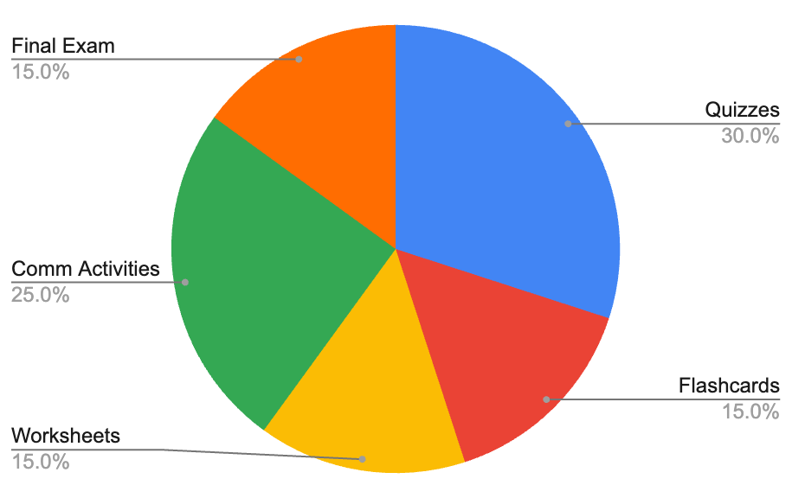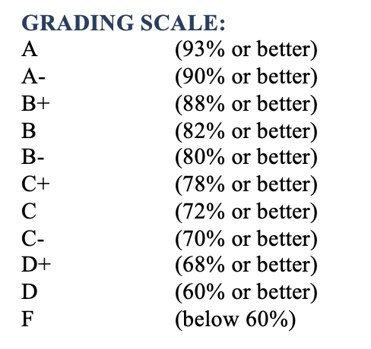
GRADE ADJUSTMENTS: It is unethical and in direct violation of the UF Student Honor Code to request an unjustifiable (e.g., “rounding up”) grade adjustment (UF Student Honor Code: “Conspiracy to Commit Academic Dishonesty”).

Disclaimer. This syllabus represents my current plans and objectives. As we go through the semester, those plans may need to change to enhance the class learning opportunity. Such changes, communicated clearly, are not unusual and should be expected.

Course Schedule:
A Weekly Schedule of Topics and Assignments:

Module | Module Topic | Assignments | Due Date
1 | Concepts, Suffixes, and Prefixes of Med Term | Worksheet | 9/1/2024
2 | Body Structure | Flashcards, Worksheet, Quiz | 9/1/2024
3 | Disease and Treatment | Flashcards, Worksheet, Quiz, Activity | 9/8/2024
4 | Integumentary System | Flashcards, Worksheet, Quiz | 9/15/2024
5 | Skeletal system | Flashcards, Worksheet, Quiz, Activity | 9/22/2024
6 | Muscular System | Flashcards, Worksheet, Quiz | 9/29/2024
7 | Nervous System & Mental Health | Flashcards, Worksheet, Quiz, Activity | 10/6/2024
8 | Senses: the Eye | Flashcards, Worksheet, Quiz, Activity | 10/13/2024
9 | Endocrine System | Flashcards, Worksheet, Quiz | 10/20/2024
10 | Cardiovascular & Lymphatic Systems | Flashcards, Worksheet, Quiz | 10/27/2024
11 | Blood & Immunity | Flashcards, Worksheet, Quiz, Activity | 11/3/2024
12 | Respiratory system | Flashcards, Worksheet, Quiz | 11/10/2024
13 | Digestive system | Flashcards, Worksheet, Quiz, Activity | 11/17/2024
14 & 15 | Reproductive Systems | Flashcards, Worksheet, Quiz | 11/24/2024
Cumulative Final Exam – Open from 12/2/2024 to 12/11/2024

